**Project Report : Measuring the Pulse of Prosperity**

**An Index of Economic Freedom Analysis**

**1. INTRODUCTION**

**1.1 Project Overview**

This project investigates the Index of Economic Freedom to assess the prosperity levels of various nations. By analyzing data related to government policies, taxation, property rights, and regulation, the project aims to understand how economic freedom influences national growth.

**1.2 Purpose**

The main purpose is to visualize, compare, and interpret the level of economic freedom among countries and explore its correlation with prosperity indicators using Tableau.

**2. IDEATION PHASE**

**2.1 Problem Statement**

Despite global economic growth, disparities persist. Understanding which economic policies contribute to prosperity is crucial. This project attempts to analyze and uncover patterns in economic freedom and national development.

**2.2 Empathy Map Canvas**

* **Who:** Policy makers, economists, investors, citizens
* **What they feel/need:** Transparent governance, fair trade, less corruption
* **How this helps:** Visual insights to support reforms and awareness

**2.3 Brainstorming**

Explored ideas like:

* Comparing regions/countries
* Measuring impact of policy components
* Correlation with GDP or HDI
* Creating a global economic freedom dashboard

**3. REQUIREMENT ANALYSIS**

**3.1 Customer Journey Map**

| **Stage** | **Action** | **Goal** |
| --- | --- | --- |
| Awareness | Explore global prosperity factors | Identify gaps |
| Analysis | View dashboards | Understand patterns |
| Insight | Use insights for decisions | Support reforms |

**3.2 Solution Requirements**

* Clean and comprehensive economic data
* Data visualization tool (Tableau)
* Internet connectivity and browser for Tableau Public

**3.3 Data Flow Diagram**

Dataset → Data Cleaning → Tableau Import → Dashboards → Insights

**3.4 Technology Stack**

* **Tableau Public:** Visualization
* **MS Excel / Google Sheets:** Data preparation
* **GitHub:** Project hosting

**4. PROJECT DESIGN**

**4.1 Problem–Solution Fit**

* **Problem:** Lack of awareness about how policies impact prosperity
* **Solution:** Visual insights using Tableau from economic freedom data

**4.2 Proposed Solution**

* Interactive dashboards showing scores by country, region, and category
* Insights into correlations between freedom and prosperity indicators

**4.3 Solution Architecture**

1. Import dataset
2. Clean and preprocess
3. Create visualizations
4. Share through GitHub/Tableau Public

**5. PROJECT PLANNING & SCHEDULING**

**5.1 Project Planning**

| **Week** | **Task** |
| --- | --- |
| 1 | Data collection and cleaning |
| 2 | Tableau setup and trial |
| 3 | Dashboard creation |
| 4 | Final review + report |

**6. FUNCTIONAL AND PERFORMANCE TESTING**

**6.1 Performance Testing**

* Tableau dashboards tested for:
  + Load time
  + Responsiveness
  + Filter accuracy
  + Cross-platform compatibility
* **7. RESULTS**
* **7.1 Output Screenshots**

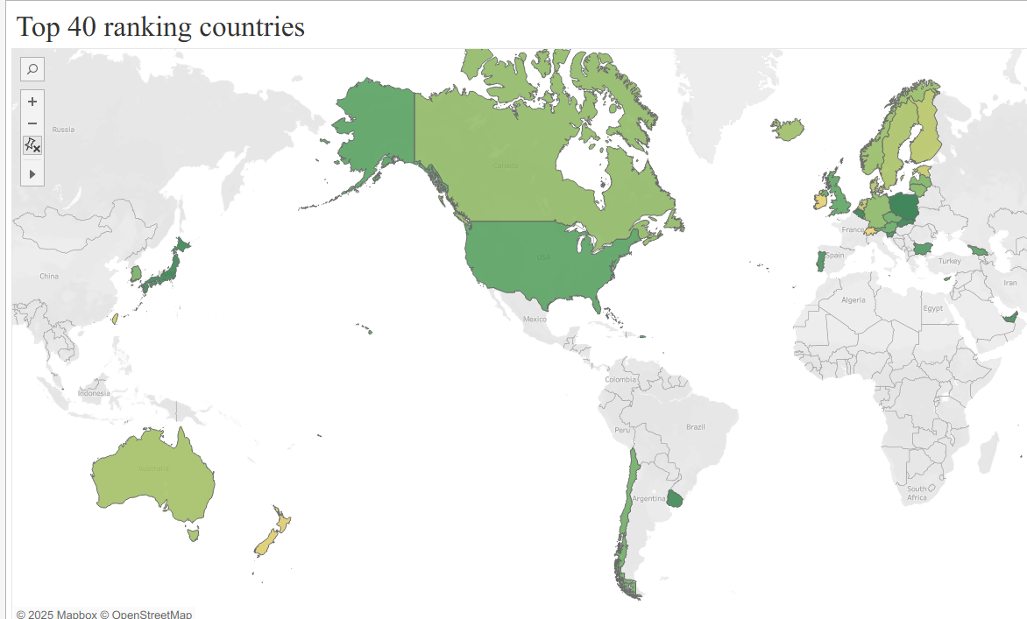

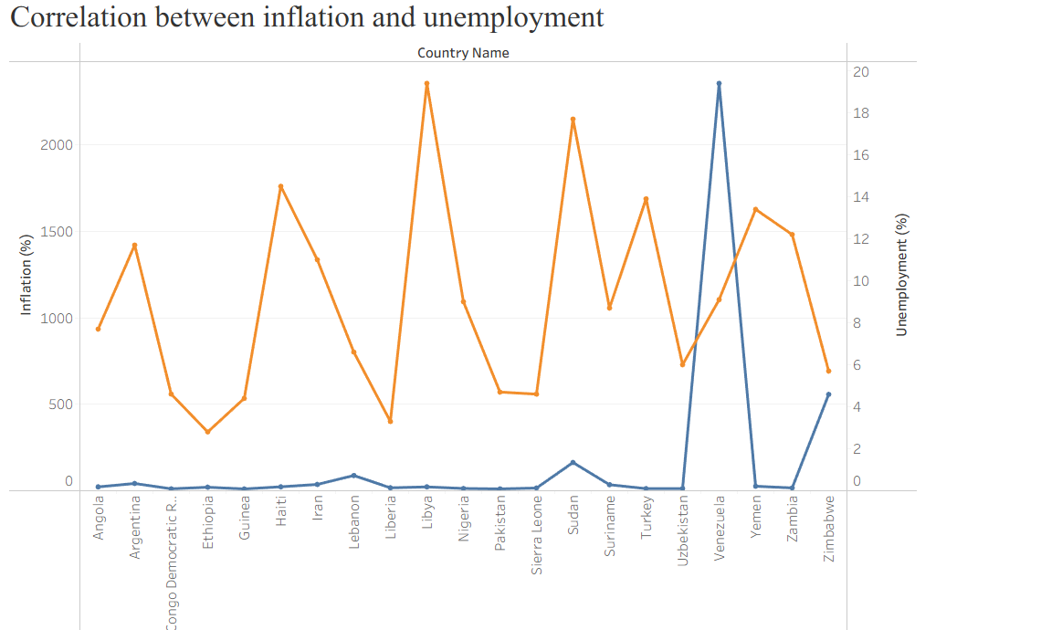

**8. ADVANTAGES & DISADVANTAGES**

**✅ Advantages**

* Easy to interpret visual insights
* Highlights key policy-performance links
* Open-source and interactive tools used

**❌ Disadvantages**

* Limited to available data
* Static data (not real-time)
* May miss local policy contexts

**9. CONCLUSION**

This project effectively highlights how economic freedom impacts a country's prosperity. Through visualization and analysis, we gain valuable insights into which factors matter most and how countries can improve.

**10. FUTURE SCOPE**

* Include multi-year trend analysis
* Compare with HDI, GINI Index, and inflation
* Build a real-time API-connected dashboard.